|  |
| --- |
| ﷽﷽﷽﷽﷽﷽﷽﷽**gure 12.gure 12.gure 12.gure 12.ASSIGNMENT 2**  **Body in Motion** |
| **An Individual Assignment**  **Presented to**  **Mr. Jacky C.K. LEUNG** |
| **In Partial Fulfillment**  **of the Requirements for the Subject**  **Body in Motion** |
| **DIPLOMA IN FITNESS AND**  **EXERCISE STUDIES**  Stage 2 |
| **Submitted by**  **NG CHUI SHAN**  **10644115**  **November 14th, 2016**  **School of Professional and Continuing Education**  **Recreation and Sports Management Section** |

**Corner Kick**

**Table 1: Muscular action during kicking preparation (Left-footed kick)**

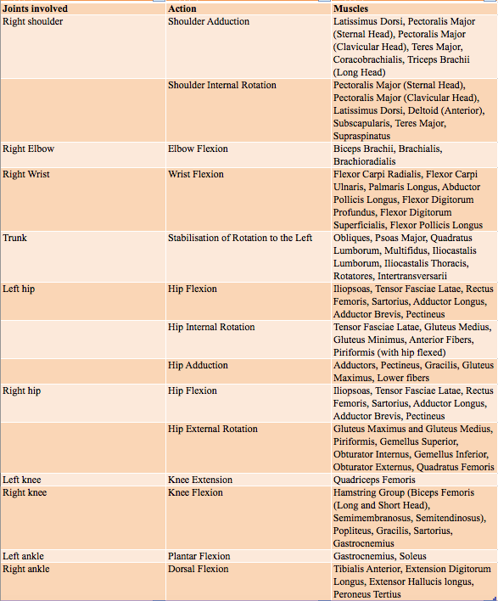

The arm opposite to the kicking leg is raised and pointed in the kicking direction to counter balance the rotating body. This creates a large joint range of motion, producing a greater force. The greater the applied force, the greater the acceleration. The player's centre of mass and base of support shift positions to stabilize the body for the critical instant.

Once the backswing ceases, the hip flexes while the knee remains flexed. As the knee gets close to the ball, hip extension slows and knee extension accelerates rapidly until ball contact. (Actually, the leg starts to slow just before ball contact.) The rapid acceleration of knee extension is what imparts a large fraction of the power for a shot or a long pass. If you want to kick the ball harder or farther, you will gain the most by kicking and a little from lifting. Be realistic about the goals of strength training. For the knee, strength training is about increasing strength to prevent injury, not necessarily to improve kicking performance.

**Table 2: Muscular action during follow-through (Left-footed kick)**

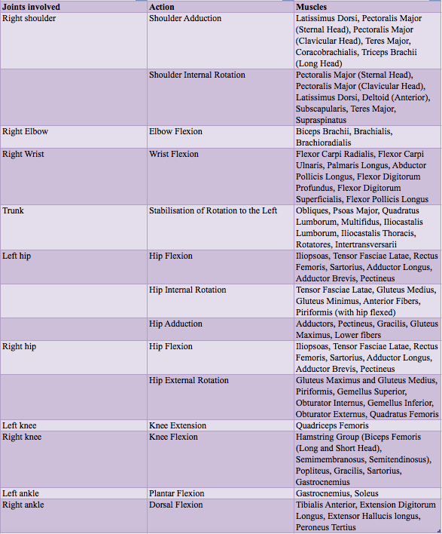

**Follow-through (這段要重新執過，因為這段在網上抄落黎)**

The key of the follow-through after a kick is the same as that of strokes in other sports , which is to keep the contact time as long as possible.

The longer the foot keeps contact with the ball, the greater is the momentum imparted. Second, a long follow-through offer protection to the body, the swinging limb in particular, to avoid injury because it dissipate the muscle and elastic force generated in the follow-through. A longer follow-through increases the time component of the impulse side of the impulse-momentum equation; it reduces the force acting back on the leg and thus reduces chance of injury

The player will bend the knees and kick the ball off the ground. After completing this action, the player's distal is not fixed on any plane. The action of the Corner kick is called the Open kinetic chain.

Open kinetic chain (OKC) is characterized by a joint chain that has its specific range of motion. The distal part has a greater range of motion than the prosimal part; it also has higher speed. OKC can be isolated to stimulate the muscles. The movement is relatively easy to grasp.

**Cable Kickback**, **Woodchopper** and **Floor wiper with Barbell** are open kinetic chain as the distal limb is not fixed in any plane, i.e., the free movement of the distal limb (foot or hand) in space. For example: Cable Kickback training, the foot was free to move as the motion involves flexion and extension of the hip joint only.

**Close kinetic chain**（CKC） is a motion in which the distal part of the limb is fixed and bear the weight of the body, and the proximal part in the fixed limb provide the foundation for the move. Usually, the motions of closed-chain motion are used more commonly in functional training. Muscles, bones, tendons, ligaments and joint capsules are under a certain load during training. The stimulation of proprioceptors of joints and surrounding tissues is more obvious than that in open-chain exercise training.

**Single Leg Depth Jump** and **Bosu Single Leg Jumps** Training, knee and hip joint flexion and extension of the movement mode, in the course of knee and hip joint angle changes, the body center of gravity is also changing, this time on the joint and its surrounding tissue ontology receptors according to the ever-changing The situation to respond to maintain the body balance and coordination between the muscles. Therefore, Close kinetic chain is a safe and effective training method to promote joint balance function, improve the coordination ability of surrounding tissues and enhance joint stability. However, Close kinetic chain participates in more joints and muscles, Kinetic chain are not easy to master.

**1. Cable Kickback**

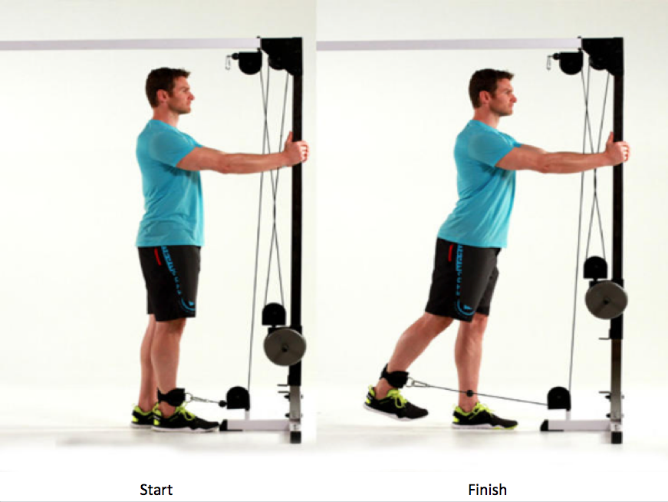

This single joint training, you can focus more training Gluteus maximus, hamstrings the active muscles, and easy to grasp.

Muscles Involved

Primary: Gluteus maximus, hamstrings

Secondary: Abdominal core for posture, muscles of the balancing leg (such as quadriceps, gastrocnemius, soleus, peroneus longus, peroneus brevis, and peroneus tertius)

Execution

Stand and face a cable machine or other stable object. Loop the rope or strap or a resistance band around one ankle. Keeping the leg as straight as possible, extend the leg at the hip (move it backward) as far as possible. Pause briefly and then return to the starting position. If necessary, hold onto the machine for balance. Switch legs and repeat with the other leg.

Focus

Any movement that results in a ball being thrown or kicked requires some sort of a windup. The longer the windup, the farther or faster the ball will go. The anatomy of the hip joint as well as a specific ligament of the hip (the iliofemoral, or Y ligament) limits the backswing of a kick. Kicking is not just about the forward swing of the kicking leg. You can increase the strength of the hip extensors so that you use as much of the motion available for the windup as possible.

**2. Woodchopper**

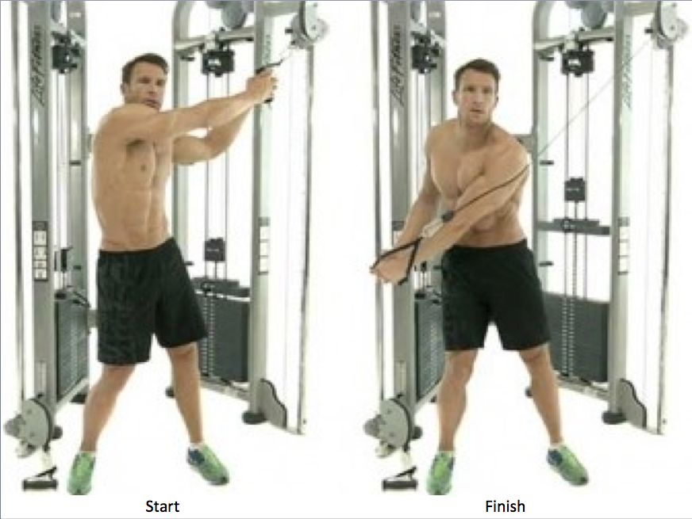

This action is more difficult than the Cable Kickback, because this action requires more stability.

Muscles Involved

Primary: Rectus abdomens, external and internal oblique, anterior and lateral deltoid, latissimus, pectorals major

Secondary: Quadriceps, gluteals, teres major, serrates anterior

Execution

Stand sideways to and a slight distance from a high pulley. Lift your arms to grasp the rope, strap, or handle with both hands. Start by pulling the rope down and across your body. As your hands pass your shoulders, twist the trunk and crunch your abs. flex your knees slightly as you continue this diagonal pull toward the opposite knee. Slowly and under control, reverse the movement to return to the starting position. After completing the desired number of repetitions, turn around and repeat the exercise in the opposite direction.

Focus

This whole-body exercise has many benefits. The action recruits the arms, trunk, gluteal, and quads in a stepwise, coordinated movement. There are no shortcuts, as one action must precede the next. On the surface, the arms and abs seem to be the focus, but the legs also play an important role as the base around which the actions occur. Pay attention to the position of the knees over the feet, and don’t let knees wobble back and forth. This is a very good functional exercise that involves multiple muscles and actions. Multijoint activities such as this are very useful supplemental exercise for the whole-body demands of team sports such as soccer. Some instructions do not include trunk flexion and the squat, making it an arm extension and trunk rotation exercise.

**3. Floor wiper with Barbell**

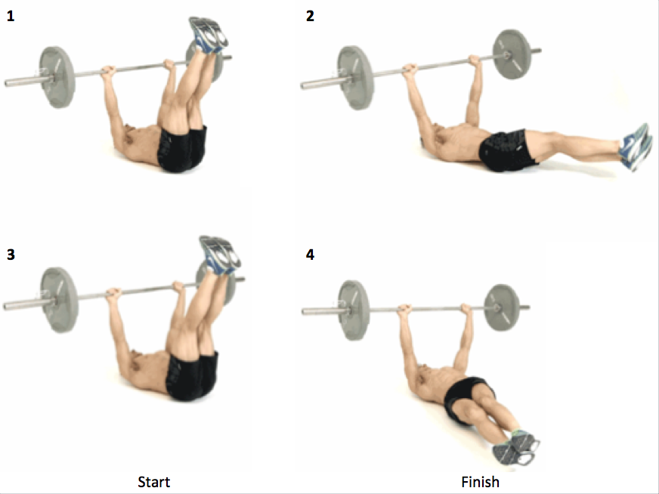

This should be fixed Barbell, upper limbs remain stable, lower them back to the floor.

Muscles Involved

Primary: Abdominal, Rectus femoris, psoas major and minor, iliacus

Secondary: Sartorius, pectorals major, triceps brachii, deltoid, serrates anterior

Execution

Lie on your back, hold an unweighted barbell above your chest. Keep arms straight. Without moving the barbell, raise your legs up toward one end of the barbell. Keep your legs straight, lower them back to the floor. Repeat, raising your legs to the opposite end of the barbell. Move the legs right and left counts as one repetition.

Focus

Hold a barbell overhead and perform hip and trunk flexion combined with a little trunk rotation. This exercise recruits multiple muscles of the core. It is quite challenging, especially when you realize the hard part of the action is to restrict the bar so that it stays overhead the entire time.

**4. Single Leg Depth Jump**

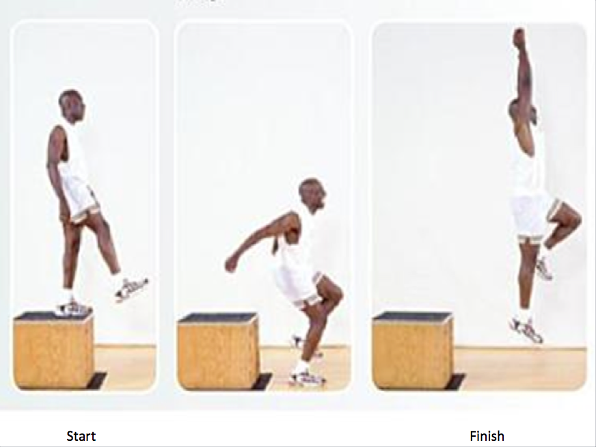

This movement mainly involve joint and muscle activity. Shoulders joint, Elbows joint, hip joint, knees joint and ankles joint. This training is relatively difficult to grasp then the previous three exercises.

Muscles Involved

Primary: Hip flexors, quadricepss, gastrocnemis, soleus, adductors Groups (adductor longus, adductor brevis, adductor magnus, pectineus, gracilis)

Secondary: Erector spinae, abdominal core

Execution

Choose a low box of about 12 inches (30cm) in height. Stand on the box with your legs at shoulder-width, rest hands and arms at your sides. Step straight off the box. Land on single feet at the time, then bring your hands up in front of you. Absorb the impact of the landing by bending at ankles, knees, and hips, sticking the landing so there are no adjustments to the impacts. Return to the box and repeat.

Focus

Prevent injuries to keep playing and improve your game. The core of injury prevention is neuromuscular control of the knees and the surrounding joints such as the ankles, hips, and trunk during demanding activities such as landing from a jump or cutting to change direction. Your goal for this exercise is to control the impact and not allow the knees to wobble right or left when landing. In addition, it is important to begin absorbing impact at the ankle and to not let the trunk waver during landing. If either of these surrounding joints shifts inappropriately, the knee must adjust, and this adjustment could put the knee in a poor position that could cause damage. Remember, these are single landings. Do not try to jump after stepping off the box.

**5. Bosu Single Leg Jumps**

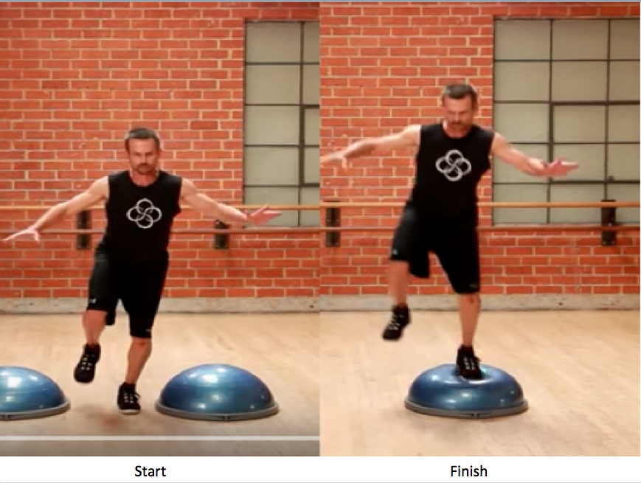

Promote joint balance function, improve the coordination of the surrounding tissue and enhance joint stability.

Muscles Involved

Primary: Quadriceps, Gluteus Maximus and Medius, Gastrocnemis, Soleus

Secondary: Abdominal core, erector spinae, hip flexors

Execution

Stand in front of a Bosu – one that will not tip over – that is midshin to knee height. Using a one-foot takeoff, jump high onto the Bosu, landing on single feet. Don’t jump just high enough to land on the Bosu. Jump higher so you are coming down on the Bosu. Jump back to your starting point, landing softly and quietly to absorb the force of the landing. Repeat in a continuous, nonstop motion. Start with 5 to 10 seconds, and add time as fitness improves.

Variation

Jump high onto the Bosu, landing on single feet, use opposite feet kick a football, landing softly and repeat again.

Focus

Jumping exercises such as this is required as there is a very high power output when player kick the football after landing on single feet, Jumping exercises can train balance, the landing with the body.

Total Word Count: 1,712 words

Reference:

Kirkendall, D.T. (2011) Soccer anatomy. Champaign, IL: Human Kinetics Publishers.

(Kirkendall, 2011)